Session 4: Data Grouping and Advanced Updates

1. Objective
To perform complex data retrieval using grouping functions, create new tables from existing data, and perform conditional updates on student records.

2. Implementation Queries
Step 1: Count Students per Course
SELECT Course_Name, COUNT(Student_ID) AS Student_Count
FROM Course
GROUP BY Course_Name;
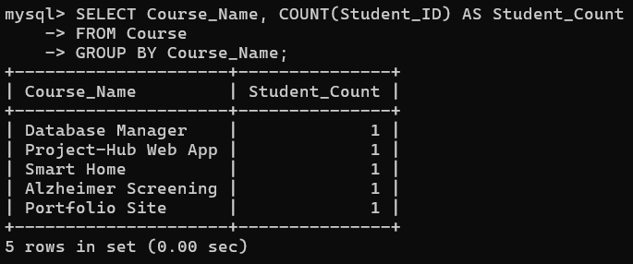
Step 2: Create a Faculty Assignment Table
Your mam wants you to select courses handled by a faculty and insert them into a new table. We will create a table called Faculty_Workload for this.
SQL
CREATE TABLE Faculty_Assignments (
Faculty_Id INT,
Course_Name VARCHAR(100),
Faculty_Email VARCHAR(100)
);

INSERT INTO Faculty_Assignments (Faculty_Id, Course_Name, Faculty_Email)
SELECT Faculty_Id, Course_Name, Faculty_Email
FROM Course;
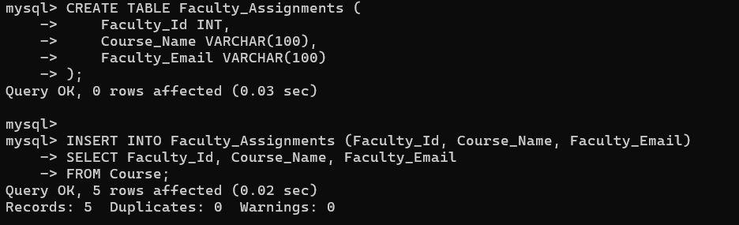

Step 3: Update Phone Numbers with Country Code
UPDATE Student
SET Phone = CONCAT('+91-', Phone)
WHERE Department = 'CSE'
LIMIT 5;
